The four phase portraits were made by executing NotchDeltaPhasePortrait.jl, and uncommenting one of the four initial state vectors. In lines 28-31.

D1=D2=0.2perturbD1 (this plot was made by uncommenting line 28, and generating a phase portrait for the corresponding x0 vector)

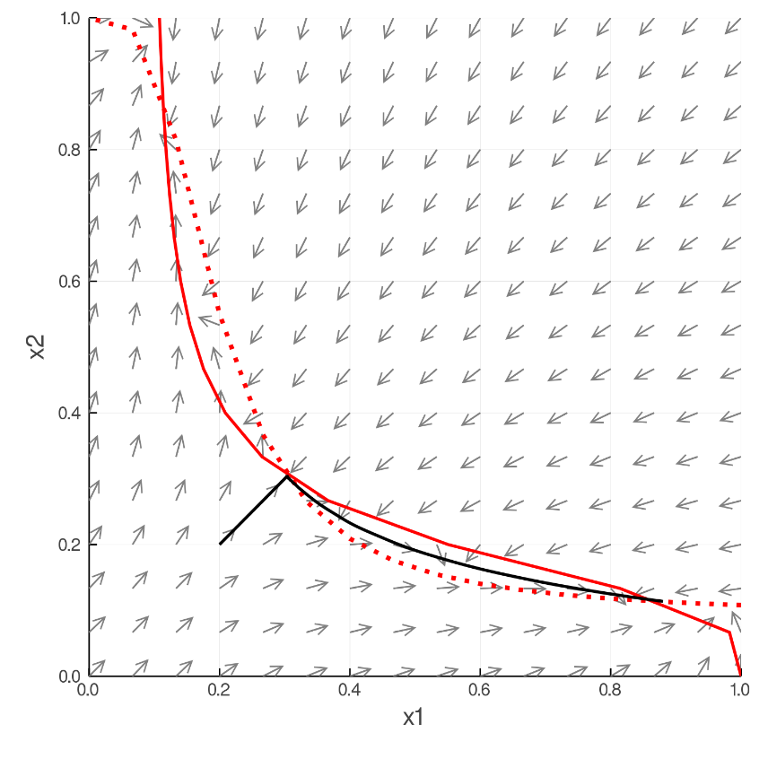

D1=D2=0.2perturbD2 (this plot was made by uncommenting line 29, and generating a phase portrait for the corresponding x0 vector)

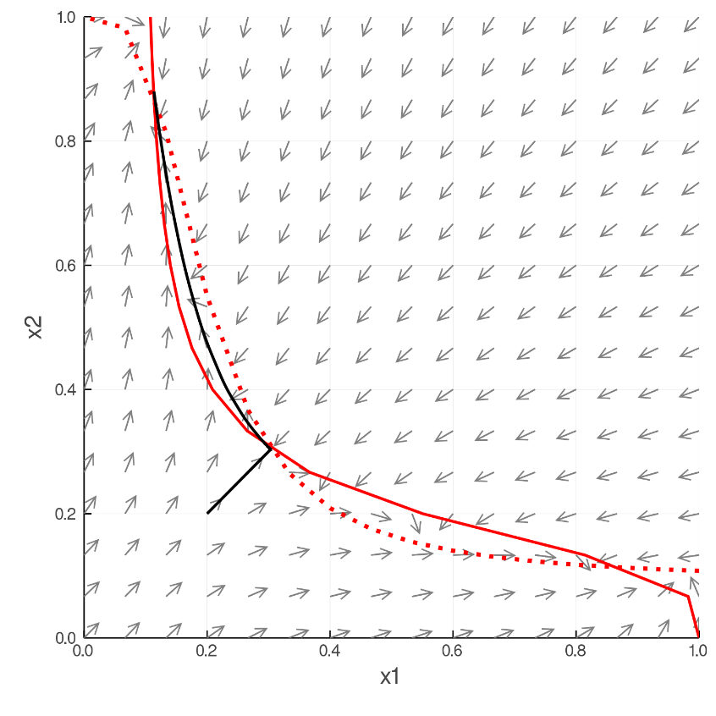

D1=D2=0.8perturbD1 (this plot was made by uncommenting line 30, and generating a phase portrait for the corresponding x0 vector)

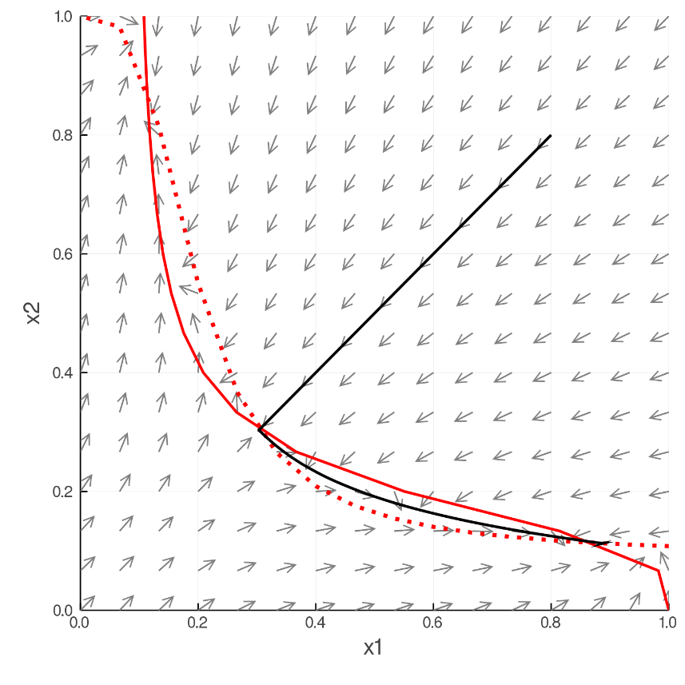

D1=D2=0.8perturbD2 (this plot was made by uncommenting line 31, and generating a phase portrait for the corresponding x0 vector)

